**CONTENT**

|  |  |  |
| --- | --- | --- |
| **S.No.** | **CONTENT** | **PAGE No.** |
| 1. | Abstract | 2 |
| 2. | Project Overview | 3 |
| 3. | System Design | 4 |
| 4. | Input Design | 8 |
| 5. | Output Design | 8 |
| 6. | Menu Level Description | 9 |
| 7. | Process Specification | 10 |
| 8. | Screen Layouts | 11 |
| 9. | Conclusion | 13 |
| 10. | Bibliography | 14 |

**ABSTRACT**

# The Job Portal Management System is a web-based application developed to streamline and automate the recruitment process for both job seekers and employers. It addresses the challenges of traditional recruitment methods, such as manual job postings, slow application tracking, and inefficient communication between job seekers and employers. By digitizing the job application and recruitment process, the system ensures enhanced efficiency, accuracy, and transparency in managing job applications and postings.

# The system provides a centralized dashboard that displays real-time data on job openings, the number of applicants, and the status of each application (e.g., Pending, Approved, Rejected). This real-time data enables recruiters and administrators to make informed decisions quickly and effectively. The process begins with job seekers registering and submitting their application forms, which include essential information such as name, contact details, resume upload, and desired job role. Once submitted, the system validates the data and updates the status of the application accordingly, automatically notifying the job seeker of the outcome.

# Built using modern web technologies such as HTML, CSS, and JavaScript, the Job Portal Management System features an intuitive and responsive interface, ensuring accessibility across various devices. It includes validation checks to ensure that the data entered is accurate, while role-based access controls limit functionalities based on user roles (job seekers, employers, or administrators). The modular design of the system allows for scalability, enabling easy future integrations with advanced features such as resume optimization tools, interview scheduling, analytics dashboards, and integration with third-party recruitment platforms.

# One of the key benefits of the Job Portal Management System is its ability to reduce the administrative burden on recruiters and improve the user experience for job seekers.

# INTRODUCTION

### PROJECT OVERVIEW

## The project entitled Job Portal Management System is a dynamic, modular, and user-centric web application developed to streamline and digitize the job application and recruitment process. This system aims to eliminate the inefficiencies of traditional paper-based job applications by providing a centralized platform where job seekers can browse job listings, submit applications, and track their application statuses. Employers and administrators can easily manage job postings and review applications, ensuring a more organized and efficient recruitment workflow.

## Through a structured application form, job seekers can enter key details such as name, contact information, resume upload, and desired job positions, facilitating smooth and error-free data collection. Once an application is submitted, the system automatically updates the administrator dashboard, showing real-time statistics like the total number of applications, the number of active job listings, and the status of applications (Pending, Approved, Rejected). The dashboard serves as a control panel for administrators, offering immediate visibility into the status of each application and enabling quicker decision-making.

## Built using HTML, CSS, and JavaScript, the Job Portal Management System is lightweight, responsive, and compatible across devices, making it ideal for use in any professional environment. The platform’s easy-to-use interface and seamless navigation enhance user experience, ensuring that both job seekers and employers can engage with the system effortlessly.

## The system operates through a logical and structured workflow, from the submission and validation of job applications to real-time dashboard updates. By automating the application process, the system reduces administrative workload and minimizes the chances of manual errors. Instant feedback and status updates further enhance transparency, communication, and user engagement.

## Moreover, the system is scalable, designed to accommodate future integration of advanced features such as:

## Resume optimization tools

## Interview scheduling systems

## Real-time chat between job seekers and employers

## Analytics dashboards for recruitment performance tracking

## In essence, the Job Portal Management System provides a comprehensive and efficient solution for modernizing the recruitment process. It not only enhances the operational efficiency of recruitment departments but also fosters a transparent, user-friendly platform that benefits both employers and job seekers alike.

## 2. SYSTEM DESIGN

### 2.1 INTRODUCTION

System design is the process of defining the architecture, components, modules, interfaces, and data structures that collectively fulfill the specified requirements of a software system. It represents the transition from understanding what a system needs to do (as identified in system analysis) to figuring out how to achieve those requirements in a structured and efficient manner. While system analysis answers the “what is” question, system design addresses the “how to” aspect of building or improving a system.

This phase plays a critical role in shaping the success of the project. It involves not only outlining technical solutions but also ensuring that these solutions align with the operational and strategic goals of the organization. System design takes the recommendations from the feasibility study and converts them into a comprehensive blueprint for development, laying the groundwork for the implementation phase.

Before diving into system design, careful planning is essential. It is important to conduct a thorough analysis of the existing system—understanding its limitations, inefficiencies, and pain points—to identify how the new or upgraded system can bring about measurable improvements. This involves evaluating how the integration of computing technologies can enhance overall performance, reduce manual effort, and streamline workflows.

The significance of system design lies in its impact on quality. Design is where the foundation for high-quality software is built. A well-crafted design not only meets user requirements but also ensures maintainability, scalability, security, and efficiency of the system. It acts as a communication bridge between the end-users and the developers by transforming user-oriented documentation into technical specifications that can be interpreted and implemented by programmers, database administrators, and system architects.

Moreover, system design is both a technical and creative endeavor. It demands a blend of analytical thinking, problem-solving, and innovation to architect a solution that is technically feasible, economically viable, and user-friendly. It also includes considering user interfaces, data flows, control logic, and hardware-software integration, all of which contribute to a system that is robust, adaptable, and efficient in meeting its intended purpose.

In summary, system design is not just a step in the development cycle—it is the foundation of a successful and sustainable software product. A strong design ensures that the final system is reliable, efficient, and tailored to meet user expectations and institutional objectives.

### 2.2 INPUT DESIGN

### 1. Job Seeker:

### Job Application Form:

### Name: Full name of the job seeker (text input).

### Email: Job seeker’s email address (email input).

### Phone Number: 10-digit contact number (numeric input).

### Resume: File upload for the resume (allowed formats: .pdf, .docx).

### Leave Type: Type of leave (Casual, Sick, Paid, etc.) (dropdown).

### Validation:

### All fields are mandatory.

### Phone number must be exactly 10 digits.

### Email must follow valid email format.

### Resume must be uploaded in the allowed format.

### 2.3 OUTPUT DESIGN

### 1. Administrator Outputs:

### Job Seeker Outputs:

### Application Submission Confirmation:

### On successful submission, a popup appears: “Job application submitted successfully.”

### The user is redirected to a confirmation page or remains on the dashboard, displaying submitted applications.

### Application Status:

### After admin review, the status of the application is displayed as:

### Pending

### Approved

### Rejected

### Error Feedback:

### If required fields are missing or invalid, error messages are shown next to specific fields.

### Form submission is prevented until corrections are made.

### 2. Administrator Outputs:

### Job Application Review:

### Displays a real-time list of all applications with:

### Job Seeker Name

### Job Title

### Application Status

### Action buttons (Approve/Reject)

### Job Dashboard Overview:

### Displays metrics such as:

### Total number of applications

### Number of applications approved

### Number of applications pending/rejected

### Job Listing Management:

### Displays all current job listings with details such as:

### Job Title

### Company Name

### Job Description

### Location

### Salary Range

### Apply button (for job seekers)

### Error Feedback:

### If there are issues with job postings or application forms, error messages are displayed to guide the admin in fixing the issue before proceeding.

## 3. SYSTEM DEVELOPMENT

### 3.1 MENU LEVEL DESCRIPTION

###### The Menu Level Description for the Job Portal Management System is organized as follows:

### 1. Login Menu:

### Homepage:

### The main landing page for users (job seekers, students, or professionals) to enter their login credentials.

### Fields: Username and Password

### Authentication Result:

### On successful login, the user is redirected to the appropriate dashboard based on their role (Job Seeker or Admin).

### On login failure, an error popup is displayed indicating incorrect credentials.

### 2. Job Application Menu (Job Seeker View):

### Job Dashboard:

### Displays a list of available job openings.

### Each job entry includes:

### Job title

### Company name

### Location

### Job description

### Salary range

### Apply button

### Job Application Form:

### Allows the job seeker to apply for a job.

### Fields include:

### Name

### Email

### Phone Number

### Resume (Upload field)

### Includes a Submit Application button to submit the application form.

### Form validation ensures all fields are filled and the resume is uploaded in the correct format.

### 3. Job Application Review Menu (Admin View):

### Admin Dashboard:

### Displays a list of all job applications submitted by users.

### Each application shows:

### Applicant Name

### Job Title

### Application Status (Pending / Approved / Rejected)

### Action buttons to approve or reject applications

### Job Application Management:

### The administrator can view detailed information of each application and take necessary actions:

### Approve or Reject each application.

### Update Status and Notify the job seeker.

### 4. Job Listing Management Menu (Admin View):

### Job Listing Dashboard:

### Displays a list of all current job postings.

### Each entry includes:

### Job title

### Company name

### Location

### Salary range

### Job description

### Add New Job Listing:

### Allows the admin to add new job postings.

### Fields include:

### Job title

### Company name

### Job description

### Salary range

### Location

### Qualification required

### Includes a Post Job button to submit the new listing.

### 3.2 PROCESS SPECIFICATION

Process specification is a systematic approach used to define, analyze, and document the logical steps involved in converting user input into system output. In the Job Portal Management System, the process specification outlines how user registrations, job applications, and administrative functions are handled, validated, and reflected in real-time updates. This ensures system accuracy, reduces manual effort, and supports future scalability.

**1. Job Application Submission:**

**Step1:**The user (job seeker) accesses the Job Application Form and enters all required fields:

* Name
* Email
* Phone Number
* Resume (upload field)

**Step2:**  
The system performs validation to ensure:

* All required fields are completed.
* The email follows a valid format.
* The phone number is 10 digits.
* A valid resume file is uploaded (in an acceptable format, e.g., .pdf, .docx).

**Step3:**  
Upon successful validation, the form data is submitted and stored in the system.

* A success popup appears: “Job application submitted successfully.”

**2. Job Listing Display:**

**Step1:**  
Upon login, the user is redirected to the Job Dashboard where job listings are displayed.

**Step2:**  
The system fetches available jobs and displays them in a card layout format, showing:

* Job title
* Company name
* Location
* Job description
* Salary range
* Application button

**Step3:**  
The user can click the Apply Now button for each listing to submit their application.

**3. Job Application Review (Admin View):**

**Step1:**  
The administrator accesses the Admin Dashboard to view and manage all job applications submitted by users.

**Step2:**The system retrieves and displays all applications in a tabular or card format, including:

* Applicant’s Name
* Job Title
* Application Status (Pending, Approved, Rejected)

**Step3:**  
The administrator selects an application to review and update the status.

* The administrator can approve or reject the application.

**Step4:**  
The application status is updated dynamically, and an email notification is sent to the applicant with the status.

**4. Access Control:**

**Step1:**Only authenticated users (job seekers and administrators) can access the system.

* Job seekers can submit applications and view job listings.
* Administrators can manage job applications and listings.

Step 2:  
Unauthorized users (e.g., non-registered individuals) are restricted from accessing sensitive data or performing actions on the system.

**5. System Maintenance and Scalability:**

**Step1:**  
The system allows for future enhancements such as:

* Adding new job categories.
* Modifying the job application process.
* Integrating job seekers' profile management.

**Step2:**  
Future features could include:

* Real-time chat functionality between job seekers and employers.
* Salary negotiation features.
* Analytics dashboard to track application statistics and trends.
* Integration with external recruitment platforms for broader job posting capabilities.

This process specification ensures the Job Portal Management System operates efficiently, remains secure, and can scale with the growing needs of both job seekers and employers.

**4. SYSTEM TESTING**

**4.1 SCRREEN LAYOUTS**

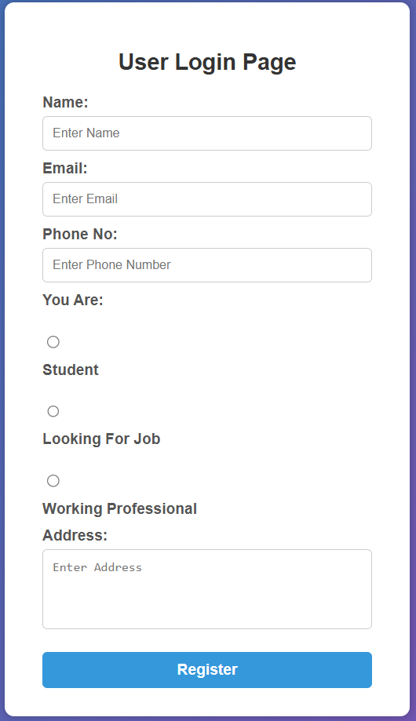

User Registration Form



Registration Success Popup

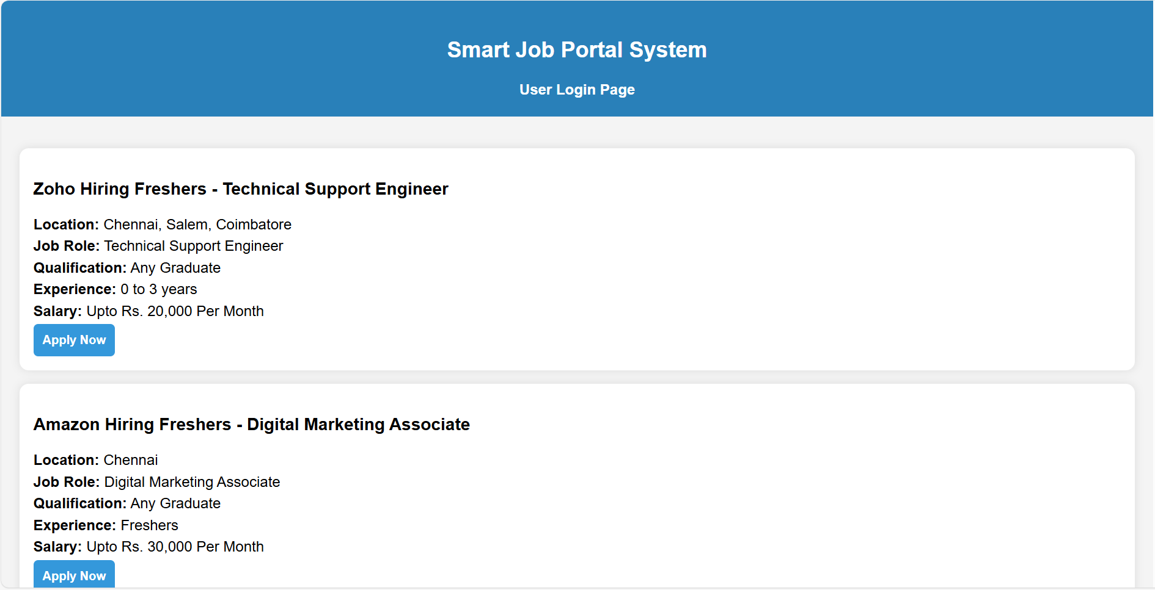

Job Portal Dashboard

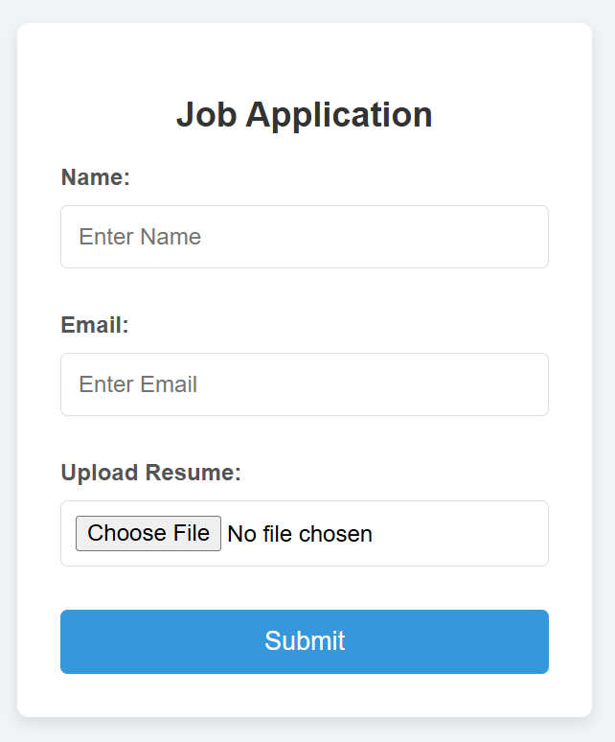

Job Application Form

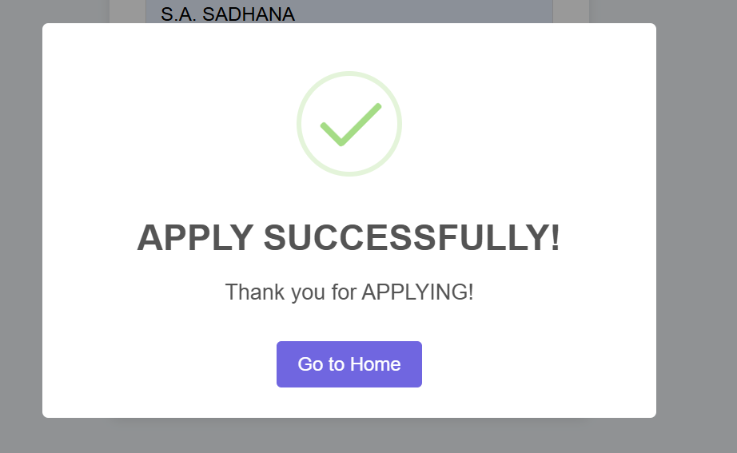

Apply Success popup

## 5. CONCLUSION

## The Job Portal Management System is an intuitive, user-friendly web application designed to streamline and automate the recruitment process for both job seekers and employers. By replacing traditional manual processes, this system allows for faster job applications, transparent communication, and efficient record management. It offers a seamless platform for students, job seekers, and professionals to apply for jobs and track the status of their applications.

## Through a structured job application process, users can easily browse available job openings, apply directly, and receive timely updates about the status of their applications. The system is designed with a role-based access control system, ensuring that users have access only to the features relevant to their role, which enhances security and usability.

## For employers and administrators, the system simplifies the recruitment process by providing a centralized platform to view and manage applications. The automated features such as status updates, email notifications, and easy tracking of applicants reduce manual effort and increase operational efficiency.

## On the technical front, the Job Portal Management System is a lightweight, responsive, and modular application that is adaptable for a wide range of users and organizations, from small startups to larger enterprises. The flexible architecture ensures scalability, allowing for future integration with advanced features like resume optimization, interview scheduling, and applicant tracking systems.

## By creating a digital record trail for all applications, the system supports better compliance, reporting, and performance tracking, making it an invaluable tool for both recruiters and job seekers. As recruitment practices continue to evolve, the Job Portal Management System aligns with the growing demand for automated, data-driven recruitment solutions that promote efficiency, accuracy, and transparency.

## 6. BIBLIOGRAPHY

1. OpenAI: "GPT-3: Language Models for Text Generation." https://[www.openai.com](http://www.openai.com/)
2. GeeksforGeeks: "Computer Science Portal." [https://www.geeksforgeeks.org](https://www.geeksforgeeks.org/)
3. YouTube: “Various Tutorials and Educational Content." https://[www.youtube.com](http://www.youtube.com/)